Design and Implementation of a Responsive Travel Blog Website Using HTML5 and CSS3

**1. Title Page**

* **Project Title:** *Wander’s Tale – A Responsive Travel Blog Website*  
  **Submitted By:**
* *Your Name : Merwin Pinto*
* Roll Number: *2462114*
* Email: merwin.pinto@btech.christuniversity.in
* **Course:** UI/UX Design Fundamentals
* **Instructor:** *Ms. Nagaveena*
* **Institution:** Christ University
* **Date of Submission:** *13/08/2025*

**2. Abstract**

This project is a responsive travel blog website titled *Wander’s Tale*, designed to share travel experiences, photography, and destination tips. The goal was to create a visually engaging, user-friendly, and fully responsive interface using only HTML and CSS. The blog features a structured layout with a header, navigation bar, recent posts section, sidebar with categories and bio, Instagram gallery, and a newsletter subscription form. Core technologies used were HTML5 for semantic structure and CSS3 for styling, layout, and responsiveness. The final outcome is a functional, visually appealing website adaptable to desktop, tablet, and mobile devices, suitable for storytelling and photo sharing.

**3. Objectives**

* Create a clean, user-friendly interface following modern UI/UX principles.
* Develop a responsive design for all screen sizes using HTML and CSS.
* Implement semantic HTML5 tags for better structure and accessibility.
* Use CSS grid and flexbox for layout and responsiveness.
* Incorporate hover effects and interactive navigation elements.

**4. Scope of the Project**

* Front-end development only (no JavaScript or backend).
* Works on desktop, tablet, and mobile viewports.
* Built using only HTML5 and CSS3 without libraries or frameworks.
* Includes navigation, blog posts, categories, author bio, Instagram section, and newsletter signup.
* Designed for travel blogging, but adaptable for other purposes.

**5. Tools & Technologies Used**

| **Tool/Technology** | **Purpose** |
| --- | --- |
| HTML5 | Structure and content markup |
| CSS3 | Styling, layout, and responsiveness |
| VS Code | Code editor |
| Chrome DevTools | Testing and debugging |

**6. HTML Structure Overview**

* Semantic elements: <header>, <nav>, <main>, <section>, <article>, <aside>, <footer>.
* Navigation menu with anchor links for smooth scrolling between sections.
* Reusable structured sections for posts, about, categories, Instagram, and newsletter.

**7. CSS Styling Strategy**

* Internal <style> section for simplicity.
* Used Grid for Instagram and posts layout.
* Used Flexbox for navigation and footer structure.
* Media queries for mobile, tablet, and desktop optimization.
* Hover effects and smooth color transitions for interactive elements.

**8. Key Features**

| **Feature** | **Description** |
| --- | --- |
| Responsive Design | Works on desktop, tablet, and mobile |
| Smooth Navigation | Fixed top nav with hover animations |
| Interactive Post Cards | Grid layout with images and descriptions |
| Instagram Gallery | Uniform image grid layout |
| Newsletter Signup | Functional email input form (non-functional backend) |

**9. Challenges Faced & Solutions**

| **Challenge** | **Solution** |
| --- | --- |
| Non-uniform Instagram images | Used CSS grid with fixed aspect ratio |
| Layout breaking on small screens | Applied media queries to stack elements |
| Navigation link reload issue | Changed href to section IDs for smooth scroll |

**10. Outcome**

* Developed a responsive, aesthetic travel blog website using HTML & CSS only.
* Learned effective use of semantic tags, CSS Grid, and Flexbox.
* Ensured cross-device compatibility with mobile-first design.

**11. Future Enhancements**

* Add JavaScript for interactive features (carousel, form validation).
* Implement light/dark mode toggle.
* Enable backend for newsletter form.
* Add animations for posts on scroll.

**12. Sample Code**

***Section 1 : Navigation Bar***

<!-- HTML -->

<header class="site-header">

<div class="container header-inner">

<h1 class="logo"><i>Wander's Tale</i></h1>

<nav class="main-nav" aria-label="Main navigation">

<ul>

<li><a href="#top">Home</a></li>

<li><a href="#posts">Posts</a></li>

<li><a href="#about">About</a></li>

<li><a href="#insta">Instagram</a></li>

</ul>

</nav>

</div>

</header>

/* CSS */

nav ul {

list-style: none;

padding: 0;

display: flex;

gap: 1rem;

margin: 0;

}

nav a {

text-decoration: none;

color: #333;

padding: 0.25rem 0.5rem;

transition: color 0.3s ease, transform 0.3s ease;

}

nav a:hover {

color: #ff6600;

transform: scale(1.1);

}

nav a.active {

color: #ff6600;

font-weight: bold;

border-bottom: 2px solid #ff6600;

}

***Section 2: Responsive Posts Grid***

<!-- HTML -->

<section class="posts">

<h2 class="section-title" id="posts">Recent Posts</h2>

<div class="posts-grid">

<article class="post">

<img src="POST 1.jpg" alt="City street at night" height="500">

<div class="post-body">

<h3 class="post-title">Night Markets & Neon Streets</h3>

<p class="post-excerpt">

Wander through vibrant night markets filled with food, lights, and culture...

</p>

</div>

</article>

<!-- More posts -->

</div>

</section>

/* CSS */

.posts-grid {

display: grid;

grid-template-columns: 1fr;

gap: 1rem;

}

.post {

background: white;

border-radius: 8px;

overflow: hidden;

box-shadow: 0 4px 8px rgba(0, 0, 0, 0.05);

transition: transform 0.3s ease;

}

.post:hover {

transform: translateY(-5px);

}

@media(min-width: 768px) {

.posts-grid {

grid-template-columns: repeat(2, 1fr);

}

}

@media(min-width: 1024px) {

.posts-grid {

grid-template-columns: repeat(3, 1fr);

}

}

***Section 3: Instagram Grid in Footer***

<!-- HTML -->

<div class="instagram">

<h4 id="insta">Instagram</h4>

<div class="insta-grid">

<img src="POST 1.jpg" alt="Instagram image 1">

<img src="Post 2.jpg" alt="Instagram image 2">

<img src="Post 3.jpg" alt="Instagram image 3">

<!-- More images -->

</div>

</div>

/* CSS */

footer .insta-grid {

display: grid;

grid-template-columns: repeat(3, 1fr);

gap: 0.5rem;

}

footer .insta-grid img {

width: 100%;

height: 200px;

object-fit: cover;

border-radius: 8px;

}

**13. Screenshots of Final Output**

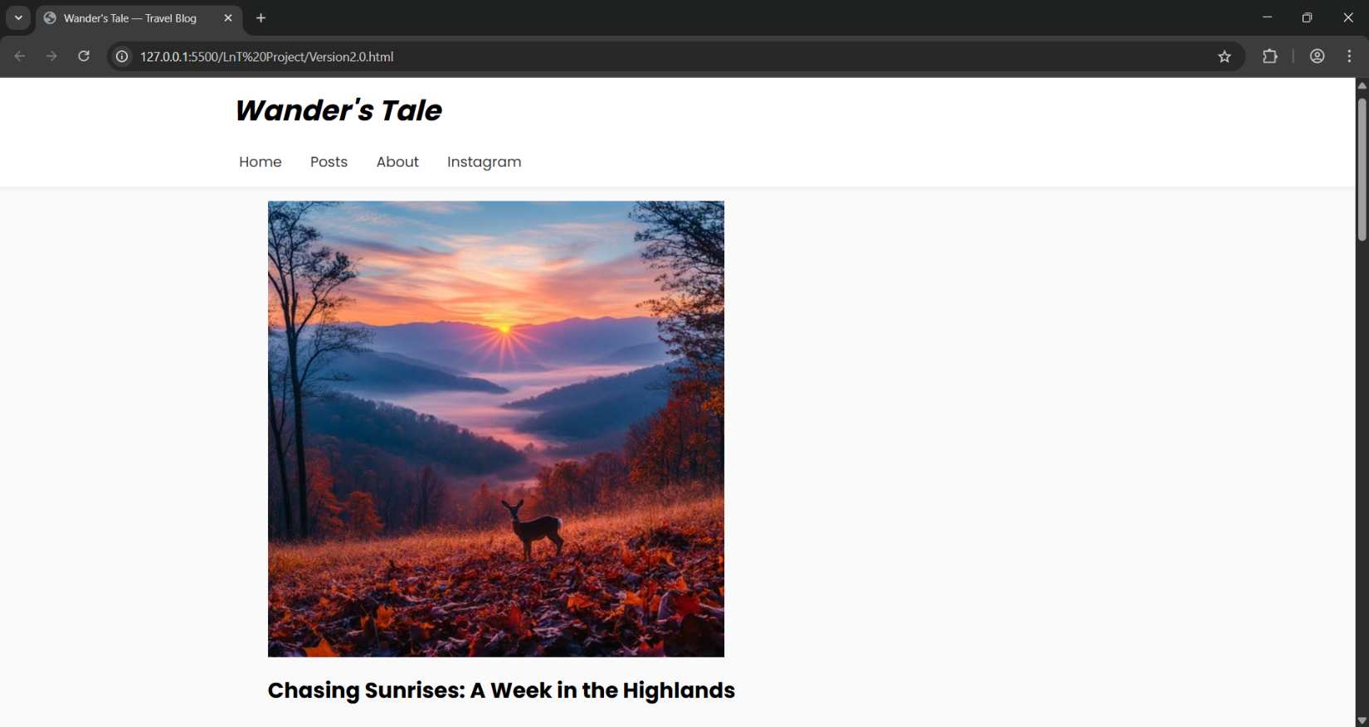

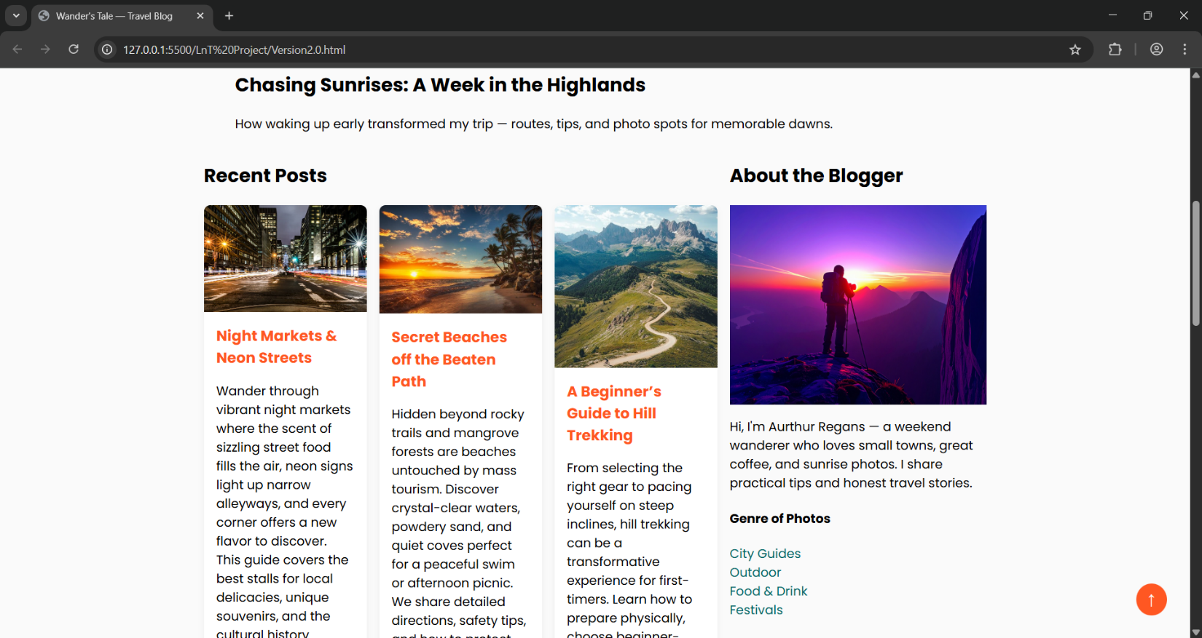

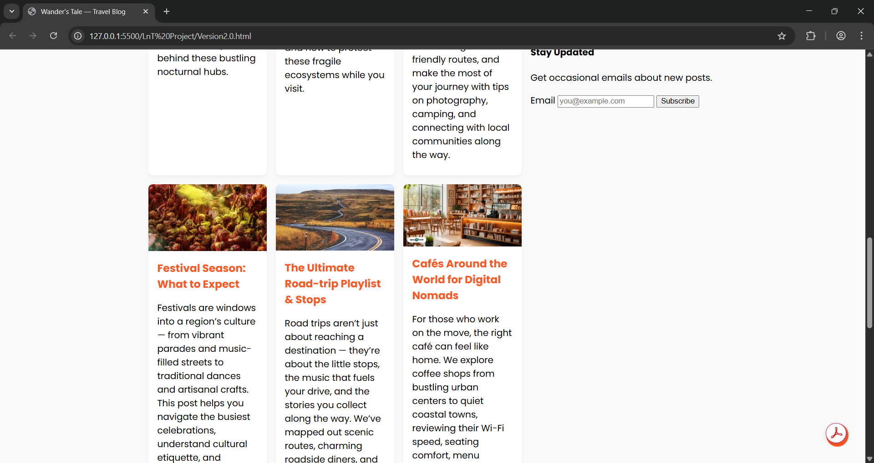

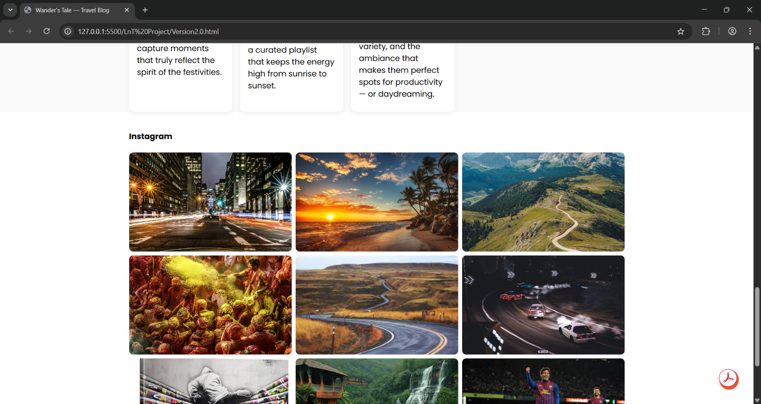

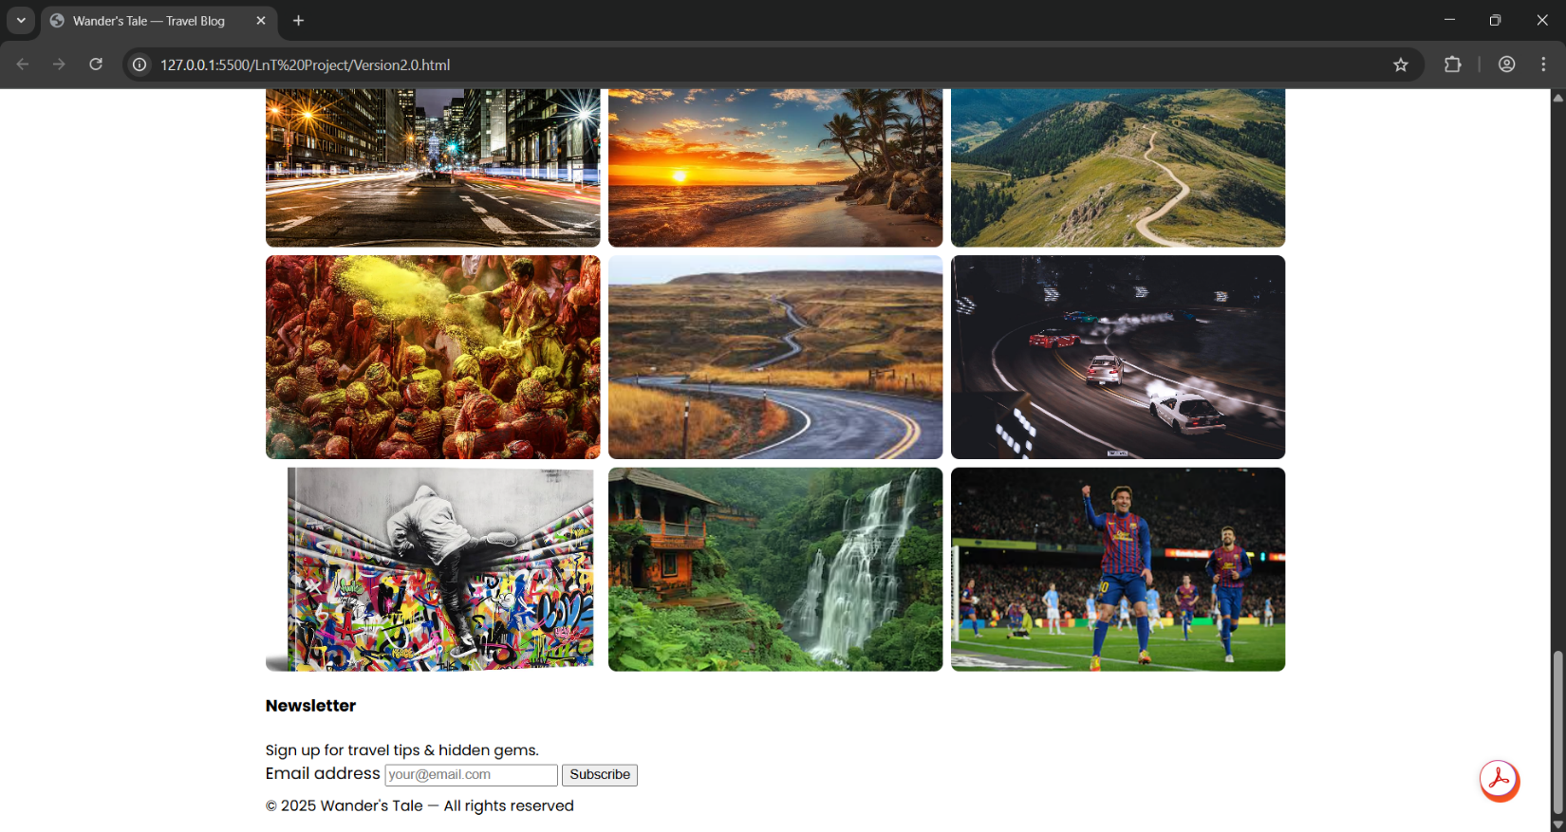

**14. Conclusion**

The *Wander’s Tale — Travel Blog* project successfully demonstrates the design and development of an interactive and visually appealing web application using HTML, CSS, and JavaScript. The project integrates responsive design principles, smooth navigation, and engaging content presentation to enhance user experience. Key features such as a scroll-to-top button, interactive hover effects, and structured content layout contribute to both functionality and aesthetics. This project not only reflects the application of core web development skills but also emphasizes creativity, user-centric design, and performance optimization. Overall, the final output meets the intended objectives of building an accessible, attractive, and easy-to-navigate travel blog platform.

**15. References**

1. Mozilla Developer Network (MDN) Web Docs — https://developer.mozilla.org/
2. W3Schools HTML, CSS, and JavaScript Tutorials — https://www.w3schools.com/
3. Google Fonts Documentation — https://fonts.google.com/
4. L&T EduTech Resources — https://www.lntedutech.com/